CLup

Covid Line up

1. INTRODUCTION
2. Purpose

This document has the purpose to clearly define the functionalities that the system-to-be will provide, the goals it strives to achieve, indicate general use cases and describe its limitations as to guide the engineers’ job and the stakeholders’ decision making.

The system tries to put an end to overcrowding inside common spaces and physical queues as much as possible, as to reduce the possibility of getting infected by Covid-19 while **doing** a daily activity such as grocery shopping. It will incentivize its users to line up virtually to go to said shops and permit to the shop managers to check how many people are inside at any time.

1. Scope

Lorem ipsum dolor sit amet, consectetur adipiscing elit, sed do eiusmod tempor incididunt ut labore et dolore magna aliqua. Ut enim ad minim veniam, quis nostrud exercitation ullamco laboris nisi ut aliquip ex ea commodo consequat. Duis aute irure dolor in reprehenderit in voluptate velit esse cillum dolore eu fugiat nulla pariatur. Excepteur sint occaecat cupidatat non proident, sunt in culpa qui officia deserunt mollit anim id est laborum.

1. Definitions, Acronyms, Abbreviations

User: PUser + VUser

PUser: Physical user, the person who goes directly to the market without using the application.

VUser: Virtual user, any person who uses the app to line up virtually and asks for a QR Code.

Ticket: QR/Bar code that permits you to enter inside the market at a certain time written on the ticket. (TBD!)

1. Revision history  
   Lorem ipsum, consectetur adipiscing elit, sed do eiusmod tempor incididunt ut labore et dolore magna aliqua.
2. Reference documents  
     
   Lorem ipsum dolor sit amet, consectetur adipiscing elit, sed do eiusmod tempor incididunt ut labore et dolore magna aliqua.
3. Document Structure

Lorem ipsum dolor sit amet, consectetur adipiscing elit, sed do eiusmod tempor incididunt ut labore et dolore magna aliqua. Lorem ipsum dolor sit amet, consectetur adipiscing elit, sed do eiusmod tempor incididunt ut labore et dolore magna aliqua.Lorem ipsum dolor sit amet, consectetur adipiscing elit, sed do eiusmod tempor incididunt ut labore et dolore magna aliqua.

1. OVERALL DESCRIPTION
2. Product perspective:
3. Scenarios

## Hajsen wishes to buy groceries but remembers that the nearest market is small, and he would probably have to wait for an hour. Instead of going downstairs and waiting in line:

* He opens the app on his phone and clicks on the button to “Get a ticket”
* He chooses the market he wants to go from a map
* The system shows the first available hour to enter the market
* Hajsen decides to go at that time and clicks on “Confirm”
* The system sends a notification to remind about his **appointment**, and Hajsen gets ready to go
* He arrives in the market in the assigned time and opens his app again
* He clicks on the “Show ticket” and scans it in the apposite machine
* After he finishes buying the groceries and paying for it, he opens the app and shows the ticket to the cashier
* Now he can exit the market

## Giulio has just remembered that he promised to her fiancée a special dinner the following day. Since it’s too late and he has no time to do the shopping, he decides to book a visit to the nearest supermarket to his home for the following day:

* He opens the app on his phone and clicks on the button to “Book a visit”
* He selects the time he would want to go
* He selects the available supermarkets for the chosen time from a map
* The system asks Giulio an estimate of how much time his visit will last and a list of items (or categories of items) he intends to buy. Since Giulio has not a clear idea of what he will purchase and how much the visit will take, he clicks on “Confirm” leaving the two previous fields empty
* The system sends a notification to remind him the visit, so Giulio gets ready to go
* He arrives in the market in the assigned time and opens his app again
* He clicks on the “Show ticket” and scans it in the apposite machine
* After he finishes to do the shopping and paying for it, he opens the app and shows the ticket to the cashier
* Now he can exit the market

## Alberto B. hates technology, so he gambles his luck and tries to enter inside the market, unfortunately there are no available places to enter so he takes a ticket from the dispenser

* He gets to the ticket dispenser in front of the shop and presses the button to get a ticket
* Reading the ticket he sees the time spot in which he can enter the market
* Since the time spot assigned is 2 hours later, he decides to do other things he had to do instead of queuing in front of the shop
* When the time is getting close to the appointment time, he gets back to the shop
* He retrieves the ticket from his pocket and scans it in the apposite machine, that lets him enter the market
* After he finishes buying the groceries and paying for it, he shows the ticket to the cashier
* Now he can exit the market

1. World and Shared phenomena details

Lorem ipsum dolor sit amet, consectetur adipiscing elit, sed do eiusmod tempor incididunt ut labore et dolore magna aliqua. Ut enim ad minim veniam, quis nostrud exercitation ullamco laboris nisi ut aliquip ex ea commodo consequat. Duis aute irure dolor in reprehenderit in voluptate velit esse cillum dolore eu fugiat nulla pariatur. Excepteur sint occaecat cupidatat non proident, sunt in culpa qui officia deserunt mollit anim id est laborum

1. 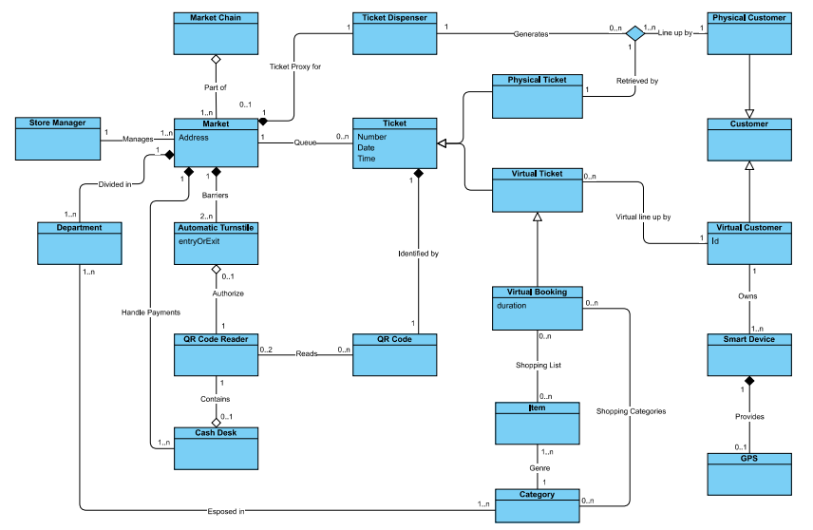Class Diagram
2. Statecharts

Lorem ipsum dolor sit amet, consectetur adipiscing elit, sed do eiusmod tempor incididunt ut labore et dolore magna aliqua. Ut enim ad minim veniam, quis nostrud exercitation ullamco laboris nisi ut aliquip ex ea commodo consequat. Duis aute irure dolor in reprehenderit in voluptate velit esse cillum dolore eu fugiat nulla pariatur. Excepteur sint occaecat cupidatat non proident, sunt in culpa qui officia deserunt mollit anim id est laborum.

1. Product functions:

Lorem ipsum dolor sit amet, consectetur adipiscing elit, sed do eiusmod tempor incididunt ut labore et dolore magna aliqua. Ut enim ad minim veniam, quis nostrud exercitation ullamco laboris nisi ut aliquip ex ea commodo consequat. Duis aute irure dolor in reprehenderit in voluptate velit esse cillum dolore eu fugiat nulla pariatur. Excepteur sint occaecat cupidatat non proident, sunt in culpa qui officia deserunt mollit anim id est laborum.

1. User Characteristics

Virtual User:

Physical User:

Cashier:

Manager: